# Day 04

1. **How to compare two JSON have the same properties without order?**
   * 1. **var obj1 = { name: "Person 1", age:5 };**
     2. **var obj2 = { age:5, name: "Person 1" };**

Ans

This can be done using isEqual() function of lodash module.

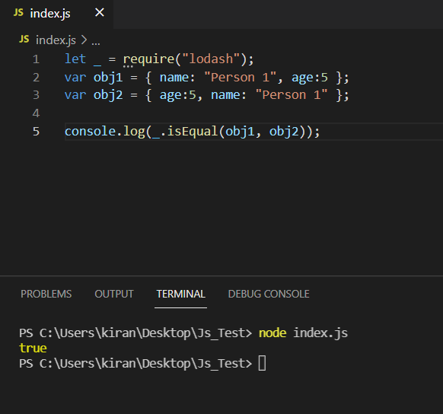

1. **Use the rest countries API url ->**[**https://raw.githubusercontent.com/rvsp/restcountries-json-data/master/res-countries.json**](https://raw.githubusercontent.com/rvsp/restcountries-json-data/master/res-countries.json) **and display all the country flags in console**

**Ans**

The flag is given as links

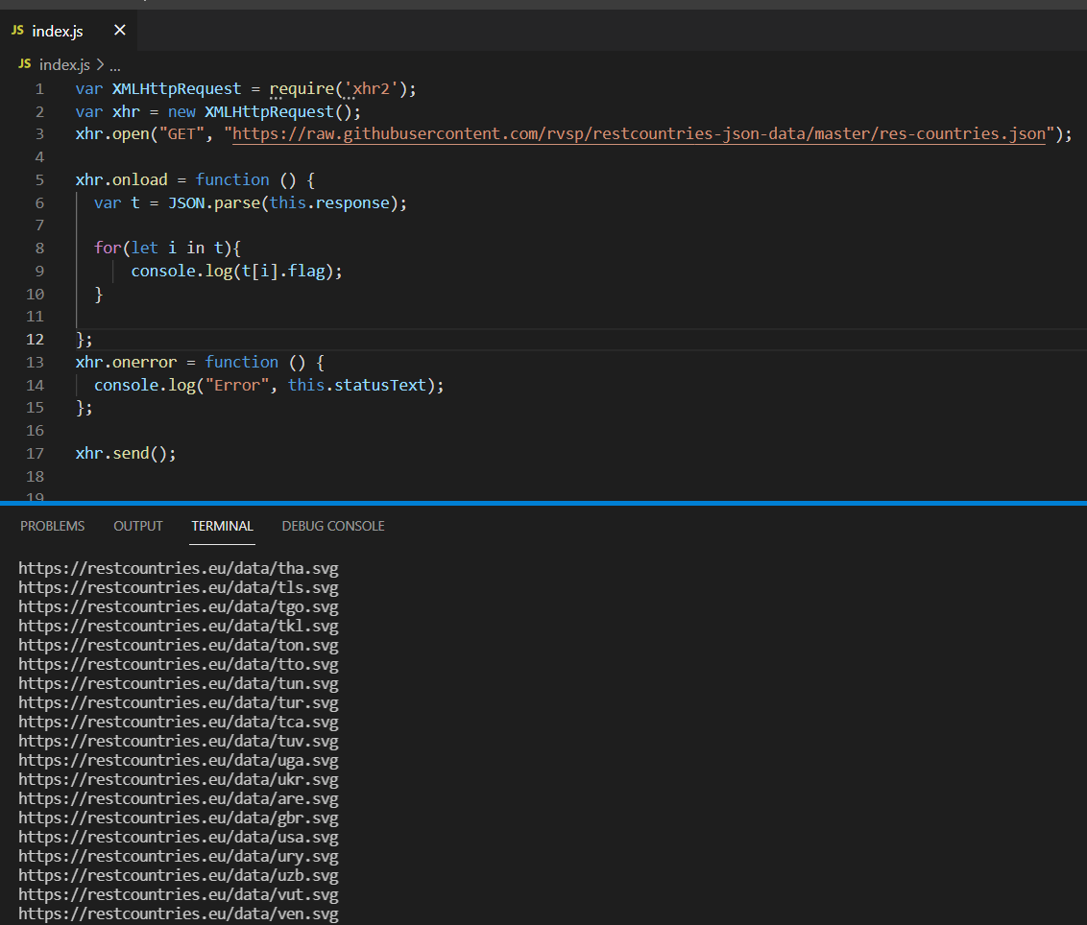

1. **Use the same rest countries and print all countries name, region, sub region and population**

Ans

